Wenjie Wireshark Lab 4

1. What is the IP address of your computer?

Answer: My computer IP is 192.168.1.4

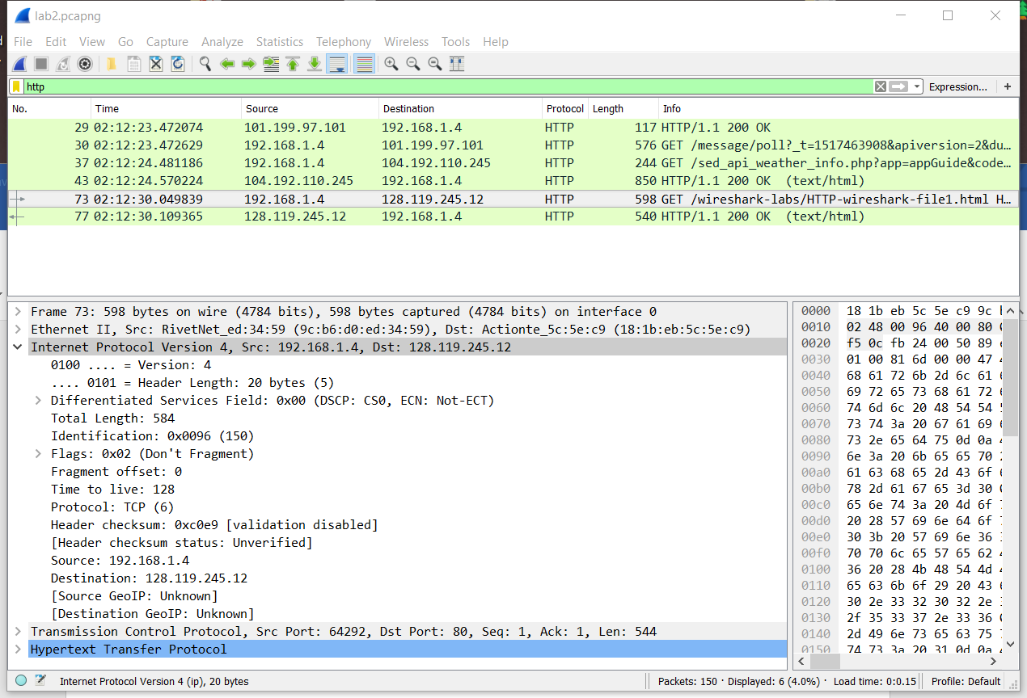

2. What is the total length of the datagram?

Answer: The total length of the datagram is 584 bytes.

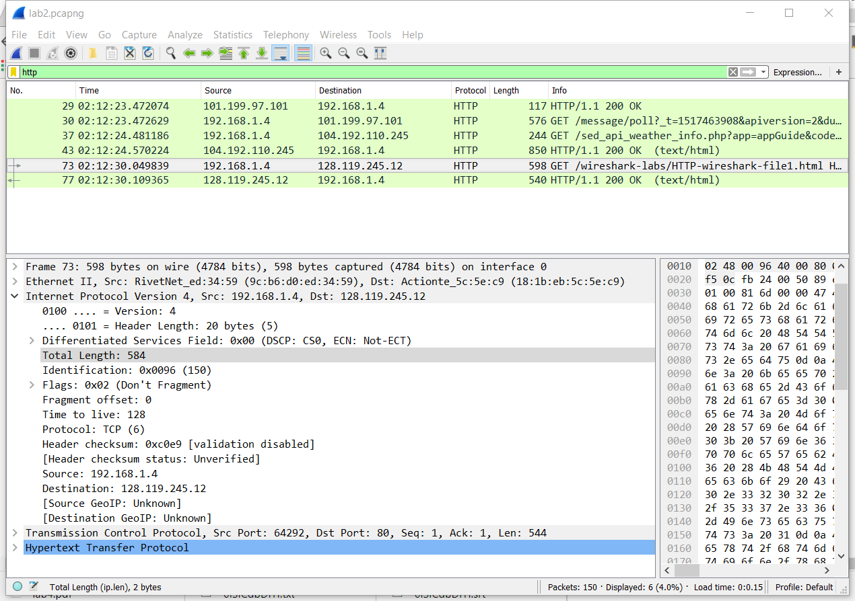

3. Has this IP datagram been fragmented?

Answer: No, the datagram has not been fragmented, because more fragments Not set is 0.

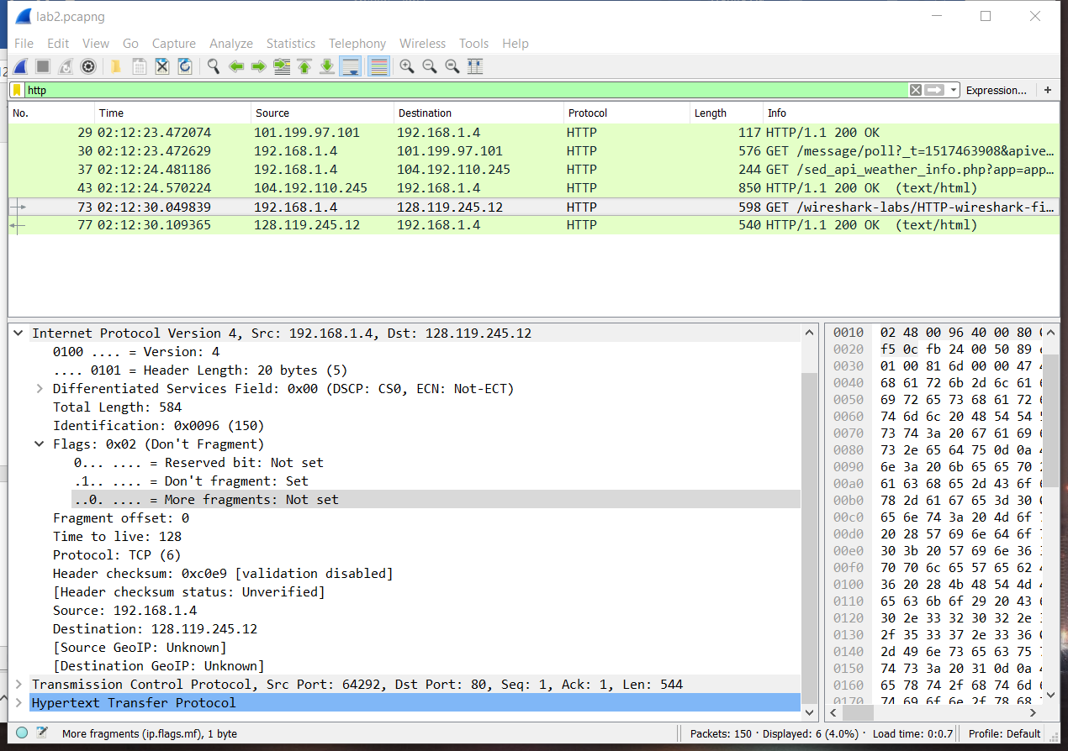

4. How many bytes are in the IP header?

Answer: there are 20 bytes in the IP header.

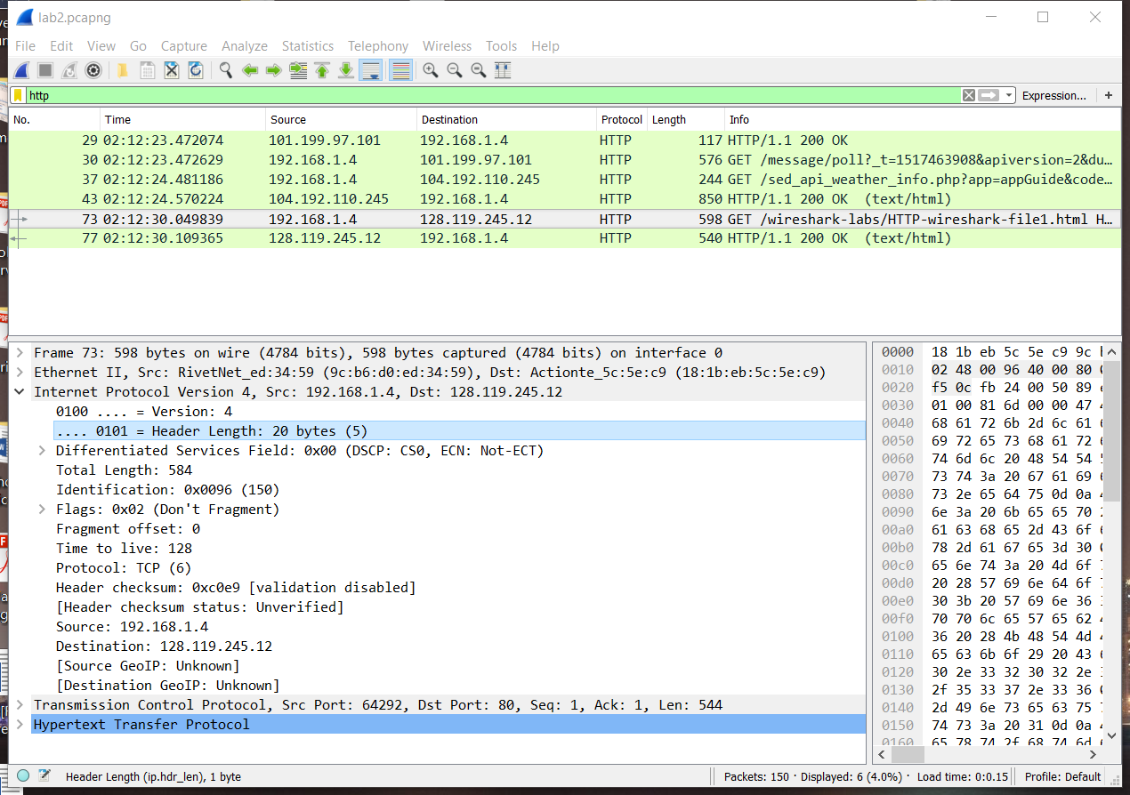

**5.** How many bytes are in the payload *of the IP datagram*? **Explain how you determined the number of payload bytes.**

Answer: There are 564 bytes for the payload of the IP datagram because my computer sent a packet of length 584 bytes which included 20 bytes in the IP header.

